**Title and acronym of the project**

ADAPTACLIMA. Adaptation to the effects derived from climate change

**Project logo**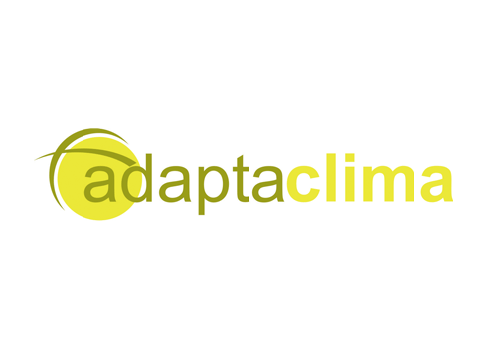

**Funding Programme**

Interreg SUDOE

**Implementation period**

2009-2011

**Coordinator**

Instituto Galego de Vivienda e Solo – Xunta de Galicia (ES)

**Countries involved**

Spain

France

Portugal

**Source of information (link)**

<https://4.interreg-sudoe.eu/ESP/f/138/21/ADAPTACLIMA/Los-proyectos-aprobados/Adaptacion-a-los-efectos-derivados-del-cambio-climatico>

**Thematic area**

Climate Change and biodiversity

Regional Planning and development

Managing natural and man-made threats, risk management

­­­­­

**Project overview**

The ADAPTACLIMA project contributes to raising awareness of the problem of climate change and its medium-term consequences on the selected territories (south-west European regions) and also to guiding the population and decision-makers at political and operational level (socio-economic actors) on the possible adaptation measures to be taken to halt the advance of climate change and minimise its effects.

**Results**

Impact assessment and analysis of vulnerabilities associated with ecological, economic and social sectors and systems.

Elaboration of climate change adaptation plans considering the integration of the different sectors and systems, valuing the different geographical and temporal areas, in order to provide relevant information in the orientation of the strategies for the use, planning and management of a territory.

Development of a strategy for adaptation to climate change, which can be applied to other areas of the SUDOE space, in response to the results obtained from the previous steps.

Application of adaptation measures to the risks derived from climate change in certain activities.