**Title and acronym of the project**

FORESTCLIM: Transnational Forestry Management Strategies in Response to Regional Climate Change Impacts

**Project logo**

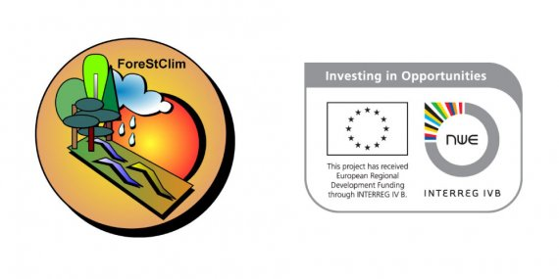

**Funding Programme**

Interreg North West Europe

**Implementation period**

2008-2013

**Coordinator**

Germany

**Countries involved**

France, Luxembourg, UK, Netherlands

**Source of information (link)**

<https://www.keep.eu/project/7044/transnational-forestry-management-strategies-in-response-to-regional-climate-change-impacts>

**Thematic area**

Land use - Forest

­­­­­

**Project overview**

The project will show regionalized climate change impacts on forest site characteristics, on forest protection functions, on forest yield, biodiversity, water resources and carbon sequestration across North-West Europe; all of this linked to a diverse set of multi-level risk assessments associated with preserving the multitude of forest goods and services, which will be part of the “ForeStClim”-strategies.

**Results**

• Comprehensive modelling of the impact of climate change scenarios on forest ecosystems in North West Europe • Tools, guidelines and methodologies for risk assessments to identify how individual forests are most at risk from climate change (e.g. wildfire, disease, storm damage, groundwater recharge, etc) or threats to goods and services (employment, timber productivity, tourism, etc) • Development of a strategic decision support system for sustainable forestry management, forest protection and water management Implementation of new site survey practices • Demonstration of new strategies at test sites