**Title and acronym of the project**

LIFE AGROGESTOR: Collective management of crops at the service of environmental programs related to the use and quality of water

**Project logo**

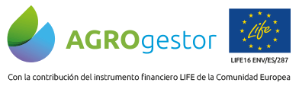

**Thematic area**

Land use-Farm

**Funding Programme**

Life

**Implementation period**

2017-2021

**Coordinator**

Spain

**Countries involved**

**Source of information (link)**

<https://www.agrogestor.es/>

­­­­­

**Project overview**

The development of the AGROgestor project will launch a demonstration of Collective Management of crop information, being an opportunity for the development of Sustainable Services in irrigated agriculture oriented to the governance of water, the efficiency in the use of water irrigation and the quality of water bodies. AGROgestor is presented as a specialized instrument for the Management of Environmental Programs by indicators in irrigation agrosystems.

**Results**

The core result of the project will be an innovative webGIS AGROgestor platform, with tools and utilities supporting the COLLECTIVE MANAGERS of farm crops to provide advice services in different environmental programmes: water governance, water efficiency and integrated handling and fertilization in vulnerable areas. This tool will be validated and demonstrated in 3 complementary pilots, representing the main environmental problems related to water use and crops fertilization.