**Title and acronym of the project**

LINKS4SOILS. Caring for Soils - Where Our Roots Grow

**Project logo**

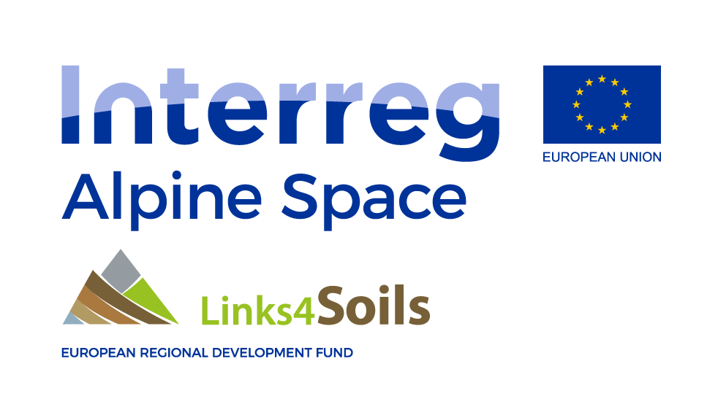

**Thematic area**

Soil and air quality.

Sustainable management of natural resources.

**Funding Programme**

Interreg Alpine Space

**Implementation period**

2016-2019

**Coordinator**

Agricultural Institute of Slovenia

**Countries involved**

Austria, Italy, Germany, Slovenia, France,

**Source of information (link)**

<https://www.alpine-space.eu/projects/links4soils/en/home>

**Project overview**

Alpine ecosystems are under increased pressure due to human influence and climate change effects. Soil is the basis of Alpine ecosystems. It is a fundamental natural resource especially in the vulnerable Alpine region. Through the sustainable management and protection of soil we will enhance the sustainable management of Alpine environment, considerably contribute to the performance and resilience of key ecosystem services, preserve biodiversity, enhance the ecological connectivity of Alpine ecosystems, and ensure human well-being.

­­­­­

**Results**

A consultancy service regarding Alpine soil management for decision-makers and stakeholders; a handbook for the implementation of soil protection in forest management practice for forest practitioners; measures and management practices regarding soil and biodiversity protection in ski/pasture areas; a protocol for the integration of soil and hydrological data; a draft of an user-oriented alpine soil classification; a web-based handbook comprising the most significant case study results and recommendations for the successful implementation thereof in management plans; new methods to provide information for use in soil ecosystem service management; the integration of Alpine soil information in the ESDAC (spatial information, protocols, web GIS); the establishment of an Alpine Soil Management Partnership; post-International Year of Soil 2015 activities, raising awareness on soil protection in the Alps; an educational/promotional video on Alpine soil, summer schools for YPAC students, etc.