**Title and acronym of the project**

PLURIFOR: Transnational Plans for the Management of Forest Risks

**Project logo**

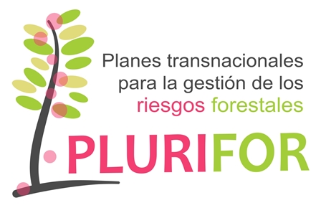

**Thematic area**

Forest risk management

**Funding Programme**

Interreg IVB SUDOE

**Implementation period**

2016-2019

**Coordinator**

EFIATLANTIC

**Countries involved**

France, Spain, Portugal

**Source of information (link)**

<https://plurifor.efi.int/>

**Project overview**

PLURIFOR aims to help with the development of regional and transnational risk management plans for forest areas susceptible to biotic and abiotic hazards.

The project will focus on the risks posed by: 1) chestnut gall wasp, 2) eucalyptus weevil, 3) fusarium, 4) pinewood nematode, 5) emerging pest and diseases, 6) forest fires, 7) soil degradation and 8) storms.

The project started by identifying the needs from regional forest services in terms of risk management and then, it developed tools (cartography, insect traps, surveillance methods, management techniques, etc.), which were integrated into existing risk management plans or new plans.

­­­­­

**Results**

The main results had been published in the project website: <https://plurifor.efi.int/>

All risk management plans are provided in the website and each tool developed has a card that can be downloaded.

Besides PLURIFOR developed Silvalert which is a website and a phone app that aims at collecting information about damages observed in forest. Each user having an account can report on a damage observed onsite by taking a picture geolocalised and sending it to the system.