* Please fill out the template in Arial font, size 12
Title and acronym of the project
PLURIFOR: Transnational Plans for the Management of Forest Risks
Project logo
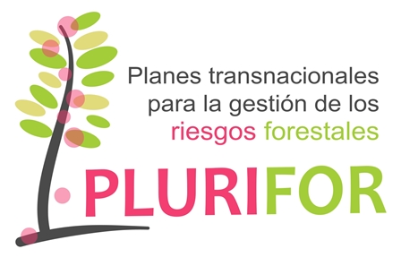

Thematic area
Forest risk management
Funding Programme
Interreg IVB SUDOE

Implementation period
2016-2019

Coordinator
EFIATLANTIC

Countries involved
France, Spain, Portugal

Source of information (link)
https://plurifor.efi.int/

Project overview
PLURIFOR aims to help with the development of regional and transnational risk management plans for forest areas susceptible to biotic and abiotic hazards.
The project will focus on the risks posed by: 1) chestnut gall wasp, 2) eucalyptus weevil, 3) fusarium, 4) pinewood nematode, 5) emerging pest and diseases, 6) forest fires, 7) soil degradation and 8) storms.
The project started by identifying the needs from regional forest services in terms of risk management and then, it developed tools (cartography, insect traps, surveillance methods, management techniques, etc.), which were integrated into existing risk management plans or new plans.

Results
The main results had been published in the project website: https://plurifor.efi.int/
All risk management plans are provided in the website and each tool developed has a card that can be downloaded.
Besides PLURIFOR developed Silvalert which is a website and a phone app that aims at collecting information about damages observed in forest. Each user having an account can report on a damage observed onsite by taking a picture geolocalised and sending it to the system.

