**Title and acronym of the project**

RAIN. Risk Analysis of Infrastructure Networks in response to extreme weather

**Project logo**

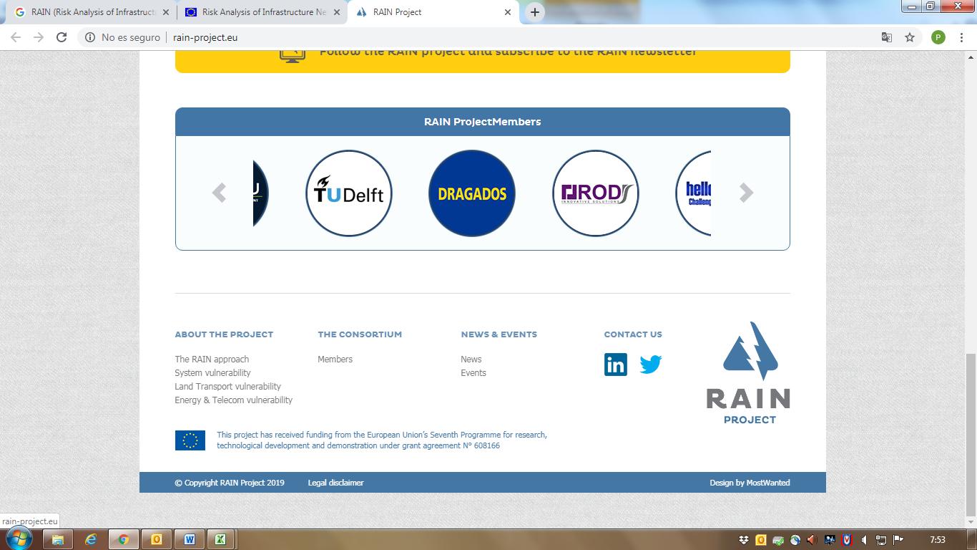

**Thematic area**

Risk Analysis

**Funding Programme**

FP7-SECURITY

**Implementation period**

2014-2017

**Coordinator**

The provost, fellows, foundation scholars & the other members of board of the college of the holy & undivided trinity of queen Elizabeth near Dublin (Ireland)

**Countries involved**

Germany, Slovakia, Netherlands, Ireland, Spain, Finland, Italy, Belgium, Greece

**Source of information (link)**

<http://rain-project.eu/>

**Project overview**

RAIN contributes to minimising the impact of extreme weather events on transport, energy and telecommunication networks. The project will develop early warning systems, decision support tools and engineering solutions to ensure rapid reinstatement of the network. This will improve reliability of critical infrastructures and reduce disruption for citizens.

­­­­­

**Results**

The RAIN project has:

* Developed an online repository of pan European gridded datasets of EWE probability of occurrence under present and future climate scenarios,
* Quantified the complex interactions between extreme weather events and land based infrastructure systems (e.g. transport, telecoms, energy etc.),
* developed an operational analysis framework (i.e. Risk Based Decision Making Framework) that considers the impact of individual hazards and the coupled interdependencies of critical infrastructure through robust risk and uncertainty modelling, considering cascading effects and time dependent vulnerability,
* Developed technical and logistic solutions to minimise the impact of these extreme weather events, through definition of early warning systems and the development of a web enabled risk based decision support tool.